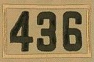

Life Scout Guide to Earning Eagle Scout

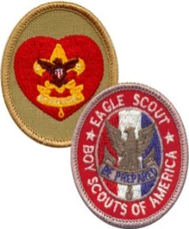

Congratulations on earning the rank of Life Scout! You are now on the final leg of your journey to making Eagle Scout. You have been a Boy Scout for a number of years but the steps to make Eagle Scout are new to you and your families. This guide is to help clarify your path to Eagle Scout.

Once you earn your Life Scout rank at the successful completion of the Board of Review, you are cleared to start work on Eagle Scout. A common roadblock that Scouts encounter at this point is that Life Scouts tend to sit back and let too much time go by before they start to work on their Eagle Scout requirements. We’ve seen it time and again! Don’t wait too long before you start the work! A common trend that we’ve been working hard to change in Troop 436 is the fact that Life Scouts are waiting until the “last minute” to get their Eagle requirements done until right before their 18th birthday. This procrastination has many detrimental effects to the Scout and the Troop:

- The Scout NEVER gets to wear his Eagle Scout rank as an active Scout in the Troop.
- A last minute push to get the project done causes MUCH undue stress not only on you, but your family, mentors, charitable organizations, Scoutmaster, Committee Chair, and District Advancement Chair.
- The Troop loses out on the valuable role model and experience of Eagle Scouts in the Troop.
- Makes an already busy junior or senior year of high school even busier.

The ideal time to earn your Eagle Scout rank is about on your 16th birthday. This gives you plenty of time to hold important leadership positions in the Troop. It also gives you plenty of time to stay active in the Troop with the big hurdle of Eagle Scout already over. Then you can enjoy time in the Troop and earn Eagle Palms at a leisurely pace. Once you earn Eagle Scout, you are also free to pursue the interests that high schoolers have outside of Scouting; friends, job, academics, college prep, family, recreation, sports, clubs, hobbies, etc.

Now that the motivation for getting your Eagle Scout is set, how do you get there? Best place to start is to go over the requirements in the Boy Scout Handbook. An explanation of what is expected of you for each requirement in more detail follows. Note they are listed in the order of the requirements however each Scout needs to prioritize them based on the age they become a Life Scout. A 17-year old Scout will likely give a higher priority to the Eagle Project then would a 15-year old Scout might for example.

- Be active in your Troop for a period of at least six months after you have achieved the rank of Life Scout.

Continue to stay active in the Troop. Active is defined by Troop 436 as attending 70% or more of meetings (90% if you hold a leadership position) and 50% or more of events and overnights. Scouts are expected to remain active with the Troop during their period as a Life Scout up to completing their Eagle Project and finally making Eagle rank. The Scout should communicate to the Scoutmaster any other positive endeavors he is involved with that are competing for time available for Scouting. Common problem here is that Scouts get too busy the longer they wait and sports, school, and other extracurricular activities get in the way of being active.

- Demonstrate that you live by the principles of the Scout Oath and Law in your daily life. List on your Eagle Scout Rank Application the names of individuals who know you personally and would be willing to provide a recommendation on your behalf, including parents/guardians, religious, educational, and employer references.

Keep living your life by the Scout Oath and Law. People are expecting more from you because you’re older and wiser. Lapses in the Oath and Law happen, even for adults, so don’t get down if these happen. Keep guiding your life, both in and out of Scouting, by the Oath and Law and you’ll do just fine!

When you complete your Eagle Project and have everything else done, you will need to fill out an Eagle Scout Rank Application. You will need references to vouch for your character for the Eagle Board of Review. You should start thinking of who these references will be. You’ll need two personal, an educational, an employer, and a religious reference.

- Earn a total of 21 merit badges (10 more than you already have), including the following:
  - First Aid
  - Citizenship in the Community
  - Citizenship in the Nation
  - Citizenship in the World
  - Communication
  - Cooking
  - Personal Fitness
  - Emergency Preparedness OR Lifesaving
  - Environmental Science OR Sustainability
  - Personal Management
  - Swimming OR Hiking OR Cycling
  - Camping
  - Family Life
  - Cooking

You must choose only one merit badge listed in items h, i, and k. If you have earned more than one of the badges listed in items h, i, and k, choose one and list the remaining badges to make your 21 total.

Even though you’ll be consumed with your Eagle project, don’t forget about merit badges! Common problems are that Scouts wait too long to get the merit badges with a time requirement to finish them. Did you know Personal Fitness takes 12 weeks and Personal Management takes 90 days to complete? Don’t forget to finish up all the non-Eagle merit badges too. The more you earn now over a total of 21 merit badges, the more you have already earned towards your Eagle Palms! If you don’t already, it’s a good idea to keep your portion of the merit badge blue card in a binder with all the signatures present. Some Council Advisors check every last one for completeness.

- While a Life Scout, serve actively in the Troop for a period of six months in one or more of the following positions of responsibility. List only those position(s) served after your Life board of review date. Senior Patrol Leader, Assistant Senior Patrol Leader, Patrol Leader, Troop Guide, Order of the Arrow Troop Representative, Den Chief, Scribe, Quartermaster, Junior Assistant Scoutmaster, Chaplain Aide, or Instructor.

An Eagle Scout is a leader and you need to keep leading to become an Eagle Scout! Just keep running for elected office or whatever other leadership position you are interested in. You do have to do your job to move on to Eagle Scout though. Common problems are Scouts not staying active in their leadership position. Scouts who do not do their assigned leadership position will NOT get credit for the 6-month leadership position required to make Eagle Scout! Your job is more than wearing the patch on your uniform. Stay active and do your job!

- While a Life Scout, plan, develop, and give leadership to others in a service project helpful to any religious institution, any school, or your community. (The project must benefit an organization other than Boy Scouting.) A project proposal must be approved by the organization benefiting from the effort, your Scoutmaster and Troop Committee, and the council or district before you start. You must use the Eagle Scout Service Project Workbook, BSA publication No. 512-927, in meeting this requirement. (To learn more about the Eagle Scout service project, see the Guide to Advancement)

This is the fun part! This is the project you are going to do to serve your community. Here are some tips for successful project completion:

Step one – Discuss your idea for an Eagle Project with the Scoutmaster and other Troop leaders. There are lots of good ideas, but some may not meet the guidelines for an acceptable BSA Eagle Project. We don’t want you wasting your time doing a lot of planning on something that won’t be approved. There are numerous websites that have helpful ideas for Eagle projects. The National Eagle Scout Association website is particularly helpful. You can also speak to Assistant Scoutmaster Lawrie as he maintains a list of potential projects where organizations around town have asked the Troop for assistance.

Once you’ve arrived on an acceptable idea that’s right for you, it’s now time to begin the detail planning and initial write-up, which will be submitted to Council for approval. Remember, you cannot begin actual work on the project until it is approved by the Council, but there is a lot of planning to be done before you get that far. You’ll also need to get permission from the Scoutmaster and Troop Committee.

Step two – Download and save the Eagle Scout Service Project Workbook to your computer. The form is modifiable and can be saved after you add your personal writing to it. Read instructions and examples in the entire workbook before you begin.

You will have to contact the organization you are working for and get their approval for the project. Later, once your application is near complete you will need their signatures again.

Here are some common problems when filling out the workbook:
- Improper spelling and grammar (yes, it counts!)
- Use a new paragraph for each new thought
- Not enough facts to show the benefit of the project
- Not enough “before” photos to show the need for the project
- Not enough proposal details on page 8 and 9
- Make sure you describe in detail each part of the work you will do (present condition, the method, materials to be used, etc.)
- Ideas not fully developed (timeline, donations, safety, etc.)
- No materials list, no basis for your estimate of money needed for fundraising

Step three – Complete the Proposal section of the Eagle Scout Service Project Workbook. Once you are satisfied with your workbook, it’s time to present your proposal to the Troop Committee. The Troop Committee meets on the first Monday of each month usually at St. Luke. Reach out to the Troop Committee Chairman, currently Mr. Arndt, to schedule time at an upcoming Committee meeting to give an introduction and preliminary proposal of your project idea. This should at least reflect the proposal section of the Eagle Scout Service Project Workbook. Be prepared to discuss all aspects of the proposed project in depth. There should be sufficient detail to ensure that the project is feasible; that safety considerations have been addressed; that action steps for further planning are included; and that you’re on the right track. Class A uniforms are required when presenting to the Troop Committee.

When the Troop Committee approves your project, you’ll need signatures from the Troop Committee Chairman as well as the Scoutmaster. The beneficiary should sign the workbook and fundraising application before obtaining the signatures of the Committee Chair and Scoutmaster. The Scoutmaster must also sign the fundraising application. Realize that the Troop Committee Chairman as well as the Scoutmaster may have further comments and suggestions and may ask to have the workbook revised yet again.

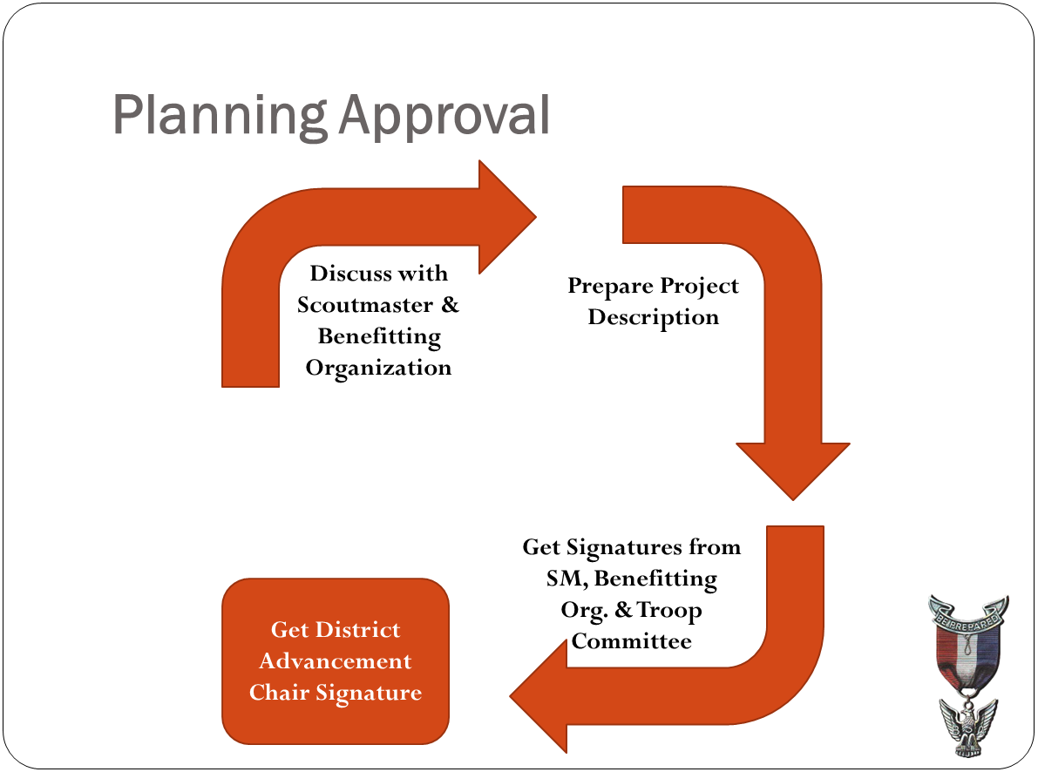

Step four – Once you have the signatures of the Committee Chair and the Scoutmaster, you will contact the Black River District Advancement Chair who will assign you a District Eagle Adviser. Review the Black River Eagle Rank Advancement Process, step six speaks to this process. You will then meet with your District Advisor to discuss your project. The District Advisor will review your workbook and may suggest changes. Once the District Advisor approves the project and signs the workbook and fundraising application, you can begin your project. Depending upon schedules, this may take a few weeks. Note you cannot do fundraising or start the project until the entire application is approved. It’s important to have a discussion about fundraising early in the process with the Troop Committee Chair and Scoutmaster. If your plan changes, go back to the Scoutmaster and tell him why you think you need to make the change.

Step five – Do the project just as planned. Be ready for changes or unexpected events – they always happen! Make sure you keep track of hours worked, money collected and spent (to the penny!), and other project details. You need to take lots of pictures too so you can clearly show before and after shots of the project. Enjoy your project and take pride in the work you do! Remember you are representing Troop 436 and the Boy Scouts of America!

- Take part in a Scoutmaster Conference.

Once your Eagle Project is complete, you need to fill out the Eagle Rank Application. This application will tie in your entire Scouting career. You’ll need the dates of your rank advancements, the dates you earned the 12 Eagle-required merit badges and 9 elective merit badges, and the dates of your last leadership roles in the Troop. The Troop Advancement Coordinator, currently Mr. Escudero, can print out your official Boy Scout Advancement report if you need those dates. It’s a good idea to get your transcript from Council so you can see exactly what they have on file. Sometimes what Council has and what Mr. Escudero has differs. Better to rectify any discrepancies before you submit your application. You’ll also need your references for this application as well as your community service certificate printed from the council’s community service tracking software that tracks the services hours spent on your project.

You will need to bring your finished Eagle Project workbook for final approval and signature by the Scoutmaster. Common items preventing the final approval for completion of project are: failure to write “thank you” notes to all who donated to your project, failure to address changes in your project, failure to provide “after” photos, failure to account for all money collected and spent, and failure to account for all materials used. Remember to finish you project to completion! Another commonly overlooked item on the Eagle Scout Rank Application is hidden in requirement 6 where a Scout must “attach to this application a statement of your ambitions and life purpose and a listing of positions held in your religious institution, school, camp, community, or other organizations during which you demonstrated leadership skills. Include honors and awards received during this service.” This should be a one page (no more, no less) typewritten essay on your ambitions and life purpose. Common problems are that Scouts do not get specific enough on this essay. While you won’t be held to what you will be doing with your life, we do expect you to write what you want to do with your life as of the day you write the essay. This is your time to write what you will do with your Eagle Scout rank!

After you Eagle Scout Rank Application is complete, contact your Scoutmaster to schedule a Scoutmaster conference. This Scoutmaster conference will last more than an hour and will be far more in depth than any previous conference you’ve experienced. On the day of your Scoutmaster conference, you must wear a full Class A uniform. The first thing you’ll do is recite the Scout Oath, Scout Law, Slogan, and Motto. The next item will be a uniform inspection. ALL patches must be correct or you will not finish your Scoutmaster Conference. Your merit badge sash must also be correct. Don’t get discouraged if all items are not ready for Scoutmaster signature at the Scoutmaster Conference. He will go over the application with a fine-tooth comb to make sure there are no errors before we submit to Council. It is much easier to correct an error at the Troop level than at the Council level. We are looking for a 100% accurate, complete, and professional looking Eagle Scout Rank Application!

- Successfully complete an Eagle Scout board of review. In preparation for your board of review, prepare and attach to your Eagle Scout Rank Application a statement of your ambitions and life purpose and a listing of positions held in your religious institution, school, camp, community, or other organizations, during which you demonstrated leadership skills. Include honors and awards received during this service.

Upon successful completion of the Scoutmaster conference, you will now take your completed Eagle Scout Service Project Workbook and Eagle Scout Rank Application to the Patriots Path Council offices in Cedar Knolls, NJ. See the WHEN YOUR EAGLE SCOUT APPLICATION AND REQUIREMENTS ARE COMPLETE document for complete instructions per Council.

The application will be closely reviewed for accuracy by the staff there. Allowing for a few weeks of process time, your assigned District Eagle Scout Advisor will work with Eagle Scout Coordinator, currently Mr. Bartnicki, to schedule your Eagle Board of Review.

This is it! The Eagle Board of Review is the final step to become an Eagle Scout. You can expect your Board of Review to be held in Long Valley, usually at the library. You must show up there in your best Class A uniform compete with your merit badge sash and your Scout handbook. Treat this like a job interview. Upon completion of your Board of Review, the board will deliberate and then bring you back in for their decision. If all goes well, from that point forward you are an Eagle Scout!

Your Eagle Scout Court of Honor is a ceremony of your family’s choice after you have passed your Eagle Board of Review. The Troop will support your family with the effort if you so choose.

Over 95 Troop 436 Boy Scouts have earned Eagle Scout and they’ve all gone through what you’re about to embark on. Keep working and focused and the prize will also be yours!

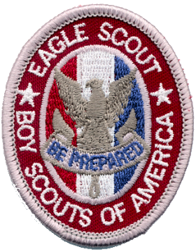

Version 12.11.17
Eagle Scout Application Checklist

SCOUT:______________________________________________________ DATE:________________________

Basic Information
⃝ Current version of the application form used, all entries printed or typed and legible
⃝ Applicant’s full name, including middle name, and complete address, no abbreviations
⃝ Type / number / city of unit – must be currently registered in the unit
⃝ Dates of joining Troop 436 (mm/dd/yy)
⃝ Dates of Board of Review for First Class, Star, and Life (mm/dd/yy)
⃝ At least four months between First Class and Star, at least 6 months since Life board of Review date
⃝ Webelos and Arrow of Light questions answered

Age Required
⃝ Date of birth
⃝ All requirements completed prior to 18th birthday
⃝ Board of review scheduled before age 18 or within three months

References
⃝ Six references listed and names provided to Scoutmaster
⃝ Letters received (unopened) from all references
⃝ Letters reviewed by District Eagle Advisor

Merit Badges
⃝ Twenty-one merit badges earned including all required merit badges
⃝ Date of completion (mm/dd/yy) and unit number for each merit badge
⃝ Merit badges not earned crossed of in No. 6 and No. 9
⃝ Any 4 required merit badges and 6 in total earned prior to date of Star Board of Review
⃝ Any 7 required merit badges and 11 in total earned prior to date of Life Board of Review
⃝ Advancement reports for all ranks and merit badges filed, accurate, and up-to-date

Leadership and Service
⃝ At least 6 months in a listed position of responsibility (see Req. 4) while a Life Scout
⃝ Dates for position(s) of responsibility – do not list “Present” or dates prior to Life Board of Review
⃝ Eagle Scout Service Project Workbook completed with final approvals prior to age 18
⃝ Project Report in workbook clearly explains leadership given in the project
⃝ Project workbook included in application package
⃝ Date of final project approval (mm/dd/yy)
⃝ Project name and total project hours entered under Req. 5 on application
⃝ Statement of ambitions and life purpose included in application package as stated under Req. 6
⃝ List of leadership positions, honors, and awards included in application package as stated under Req. 6
⃝ Community Service Coordinator enters Eagle project into Council Community Service portal.

Signatures
⃝ Unit leader conference date
⃝ Applicant’s signature and date (after completion of all requirements)
⃝ Unit leader’s signature and date
⃝ Unit committee chair’s signature and date

